Verb to be: present
Revise the theory and practice here: https://learnenglish.britishcouncil.org/grammar/a1-a2-grammar/present-simple-be

Verb to be: past:
Revise the theory here: https://test-english.com/grammar-points/a1/was-were/
Practice:
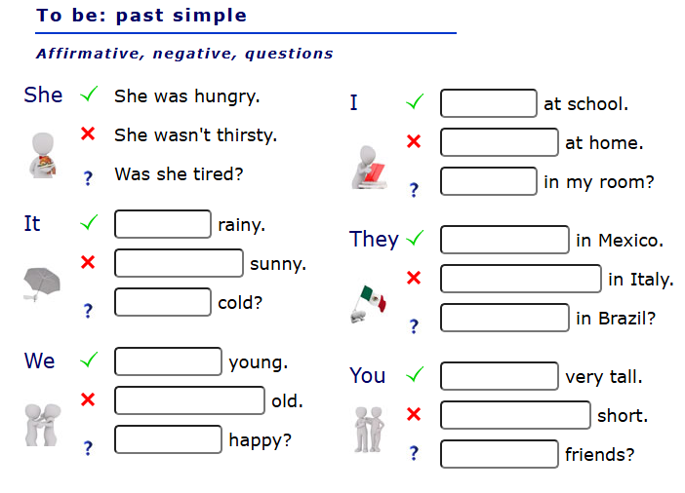
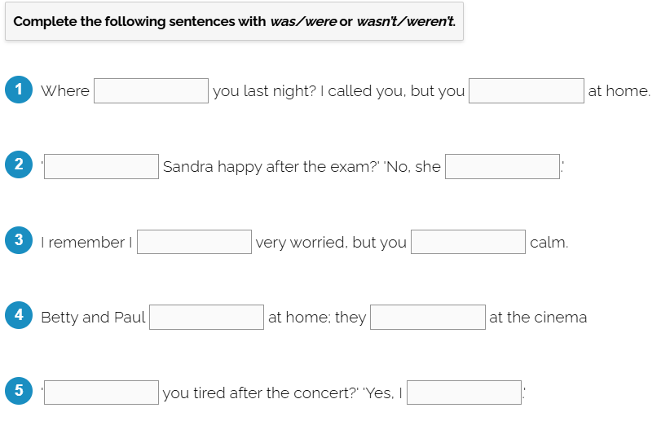

Present or past? Mixed activity:
https://www.esl-lounge.com/student/grammar/1g82-elementary-to-be-past-and-present-exercise.php

